**55) create repo**

Created the repository using nani-710

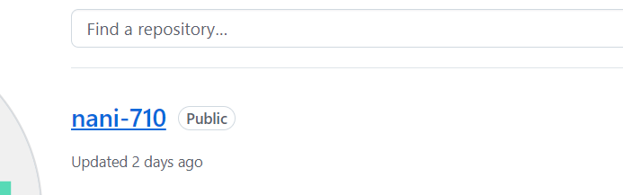

**56)create files and push to repo**

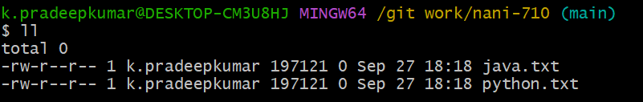

**57) Create another branch**

Created another branch as **feature**

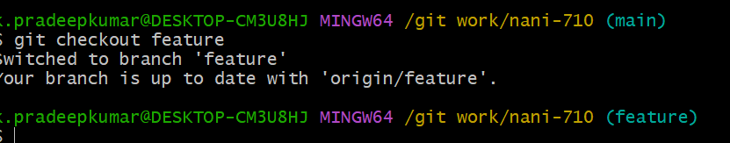

**58)add files to new branch(staging) and push back to git**

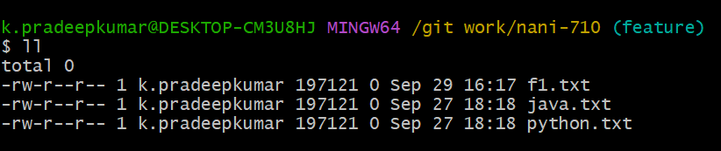

**59)create PR and merge with main branch**

The files in the feature branch be successfully merged with the main branch using

**Pull Request**

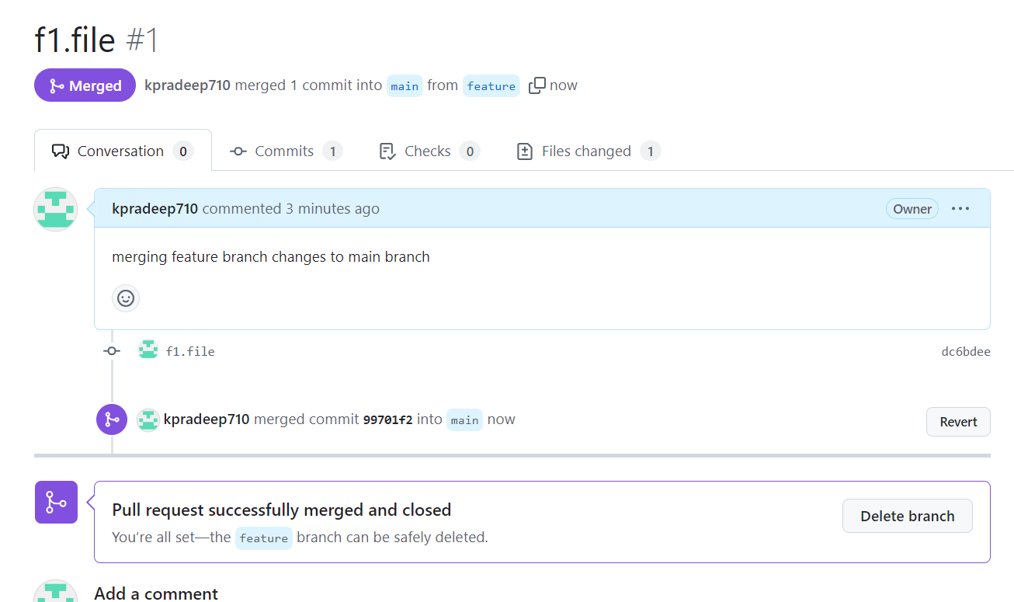

**60)create development branch and create 3files -> add 3files -> do commit -> revert 1file out of 3**

3 files f2,f3,f4 created in the **development** branch

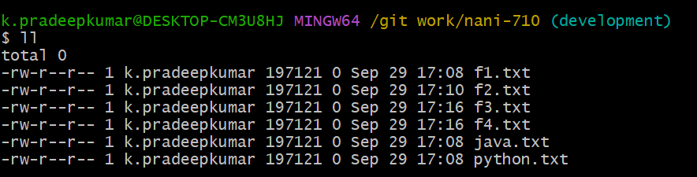

While using the revert command for **f3.txt** in the **development** branch. The f3 file be deleted from development branch

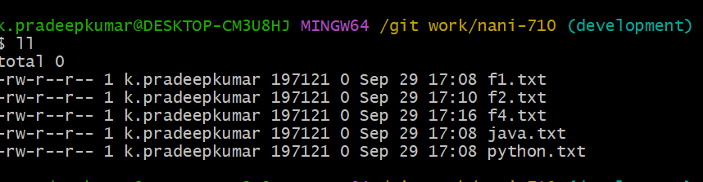

**61)create uat branch and create 3files -> add 3files -> do commit -> do push -> revert 1file out of 3**

S1.txt

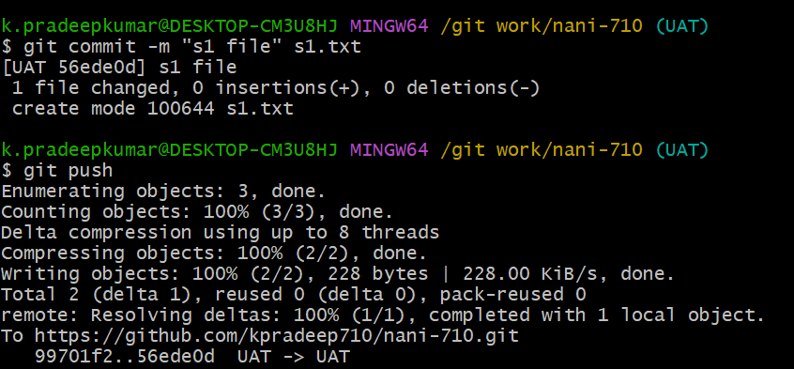

S2.txt

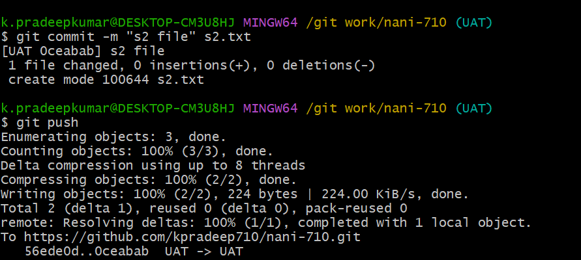

s3.txt

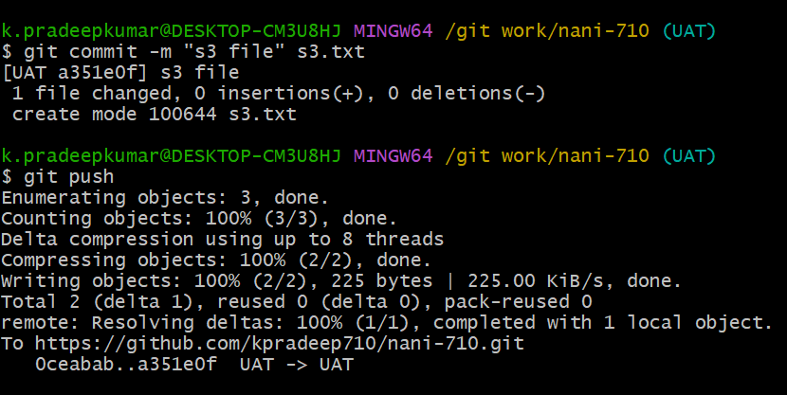

After all **s1,s2,s3** files are pushed into the **UAT** branch and then one file is deleted using **revert** command

